TITLE

Name and SURNAME of the author(s)

Affiliation, postal address and contact e-mail of each author

A brief, informative title should be provided in capital letters, and centered. Capitalize author's surnames and center them. We recommend using this template to create your manuscript by pasting your text inside.
Abstracts must be written in English. The main body of text should be less than 1000 words.

HEADER1
Header2
Headers can be used if they are useful. Primary headings should be in capital letters and centered. Secondary headings should be in bold, capital and lowercase letters and flush left.

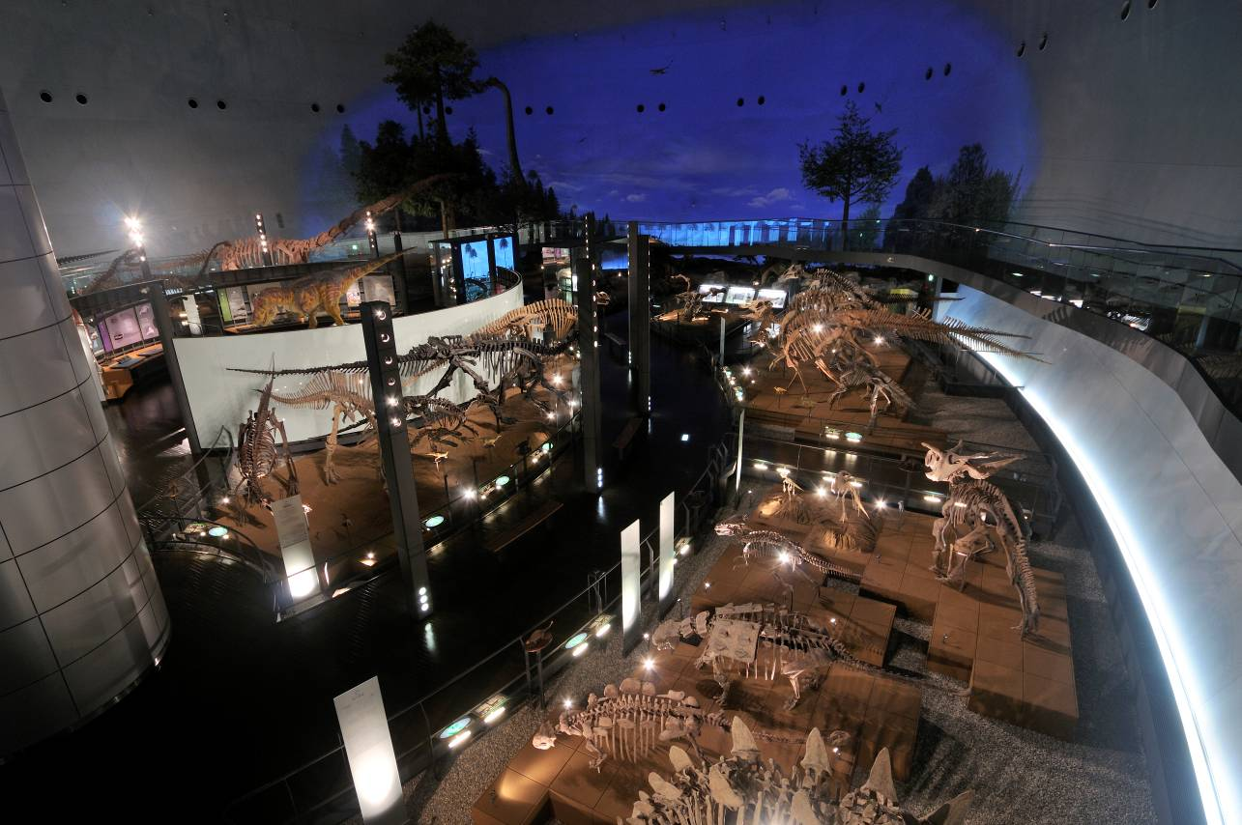
Sample, Sample, Sample, Sample, Sample, Sample, Sample, Sample, Sample, Sample, Sample, Sample, Sample, Sample, Sample, Sample, Sample, Sample, Sample, Sample, Sample, Sample, Sample, Sample, Sample, Sample, Sample, Sample, Sample, Sample, Sample, Sample, Sample, Sample, Sample, Sample, Sample, Sample, Sample,Sample, Sample, Sample, Sample, Sample, Sample, Sample, Sample, Sample, Sample, Sample, Sample, Sample, Sample, Sample, Sample, Sample, Sample, Sample, Sample, Sample, Sample, Sample, Sample, Sample, Sample, Sample, Sample, Sample, Sample, Sample, Sample, Sample, Sample, Sample, Sample, Sample, Sample, Sample, Sample, Sample, Sample, Sample, Sample, Sample, Sample, Sample, Sample, Sample, Sample, Sample, Sample, Sample, Sample, Sample, Sample, Sample, Sample, Sample, Sample, Sample, Sample, Sample, Sample, Sample, Sample, Sample, Sample, Sample, Sample, Sample, Sample, Sample, Sample, Sample, Sample, Sample, Sample, Sample, Sample, Sample, Sample, Sample, Sample, Sample, Sample, Sample, Sample, Sample, Sample, Sample, Sample, Sample, Sample, Sample, Sample, Sample, Sample, Sample, Sample, Sample, Sample, Sample, Sample, Sample, Sample, Sample, Sample, Sample, Sample, Sample, Sample, Sample, Sample, Sample, Sample, Sample, Sample, Sample, Sample, Sample, Sample, Sample, Sample, Sample, Sample, Sample, Sample, Sample, Sample, Sample, Sample, Sample, Sample, Sample, Sample, Sample, Sample, Sample, Sample, Sample, Sample, Sample, Sample, Sample, Sample, Sample, Sample, Sample, Sample, Sample, Sample, Sample, Sample, Sample, Sample, Sample, Sample, Sample, Sample, Sample, Sample, Sample, Sample, Sample, Sample, Sample, Sample, Sample, Sample, Sample, Sample, Sample, Sample, Sample, Sample, Sample, Sample, Sample, Sample, Sample, Sample, Sample, Sample, Sample, Sample, Sample, Sample, Sample,
FIGURE 1. Figures and/or tables should be attached to the MS-Word file, or made as separate files in JPEG or PDF format. Figures and tables must be numbered in the sequence they appear in the text. Use “FIGURE" and “TABLE” in the figure and table captions and numbered using Arabic numbers. Figure and Tables can occupy either one column (82 mm) or two columns (175 mm). High-quality color figures can be accepted, however, if number of color figures exceeds our expectation, some of them will be printed in grayscale.

Sample, Sample, Sample, Sample, Sample, Sample, Sample, Sample, Sample, Sample, Sample, Sample, Sample, Sample, Sample, Sample, Sample, Sample, Sample, Sample, Sample, Sample, Sample, Sample, Sample, Sample, Sample, Sample, Sample.

In-text references should be referred to the author’s name (without initials) and the year of publication. If there are multiple works, use chlonological order to refer them (e.g. Teraoka and Smith, 1986a, b; Smith, 1990).

Once the abstract is received, you will be notified of its acceptance via e-mail. After the deadline the abstracts will be reviewed by the organising committee. If we received too many proposals for oral presentations, Symposium Executive Committee will move some of them to poster presentation.

ACKNOWLEDGEMENTS
If required.

REFERENCES
Examples are as follows:
Journal Articles: Bennett, J. O., and I. M. Mead. Year. Article title. Journal Name (spelled out in full) 00: 00–00.
Journal Articles: Williams, A. B., L. A. Barnes, A. J. Read and C. D. Miller. Year. Article title. Journal Name (spelled out in full) 00: 00–000.
Books: Bennett, J. O. Year. Book Title. Publisher, Place, 000 pp.
Articles in Books: Barnes, D. B. Year. Article title; pp. 00–00 in D. O. Wilson and R. E. Bowen (eds.), Book Title. Publisher, Place.
Articles in Larger Works: Bennett, J. O. Year. Article title; pp. 00–00 in F. D. Alison (ed.), Title of Larger Work. Serial Publication 00.
Dissertations and theses: Bennett, J. O. Year. Dissertation title. Ph. D. dissertation, University, Place, 000 pp.
.

